

Department Subject Academic Year Faculty Name

STUDENT CASE STUDY EXECUTION REPORT
FED
DSA-2
I-III Semester (2025-26)

A.Kuvira
2520030192
CSE
Course Outcome 1
Student Name Roll Number Branch
Course Outcome

Case Study Topic: MediFlow Hospital — appointment-driven patient indexing using AVL Tree

Work Done Summary:

In this case study, we implemented an AVL Tree for MediFlow Hospital’s appointment-driven patient indexing system.
The AVL tree stores Patient-IDs in balanced order so that triage point-lookups remain within the hospital SLA limit.
We inserted 13 Patient-IDs into the AVL tree in appointment-arrival order and observed balancing operations like LL and RR rotations.We then performed deletion operations for transferred, discharged, and closed admissions (30, 70, and 50) and analysed the structural changes after deletion.Finally, we compared the post-delete AVL Tree performance with the equivalent plain BST using the given 5 ms SLA model.

Implementation Details:
- Inserted Patient-IDs into AVL Tree in appointment order.
- Maintained height balance using AVL balancing rules.
- Performed rotations whenever balance factor exceeded the AVL limit.
- Deleted nodes 30, 70, and 50 sequentially from the AVL Tree.
- Observed rebalancing after deletion operations.
- Compared lookup performance of AVL Tree and plain BST
- Concluded AVL Tree is better for hospital indexing because lookup remains logarithmic even after deletions.

Result: Screenshots / Output
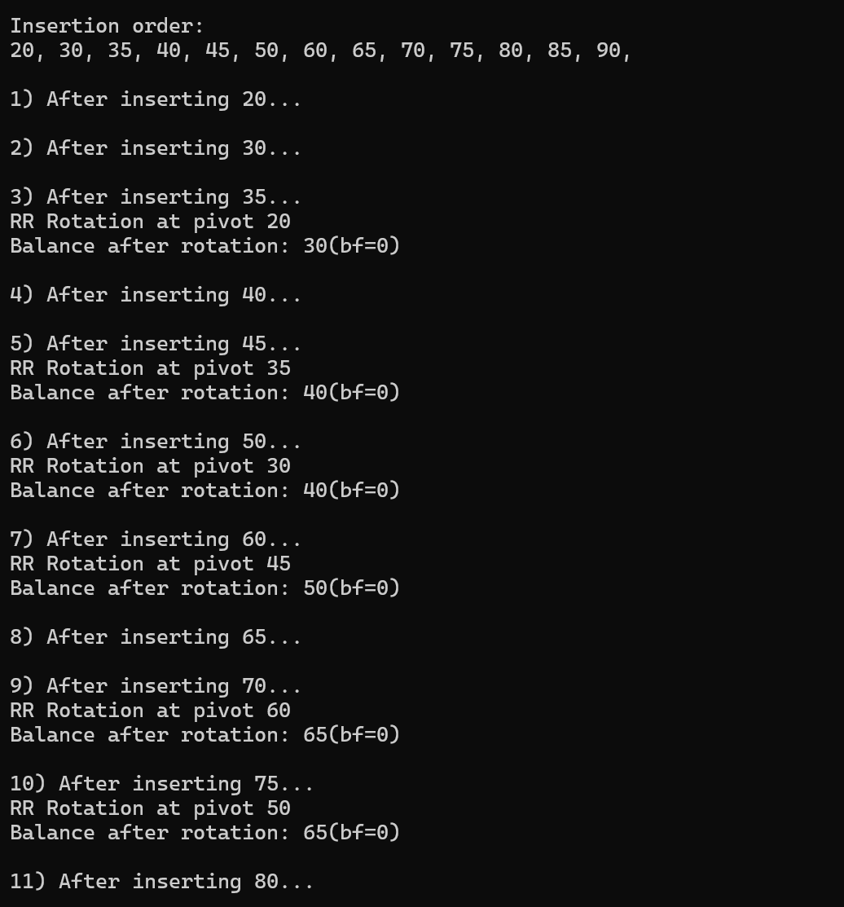
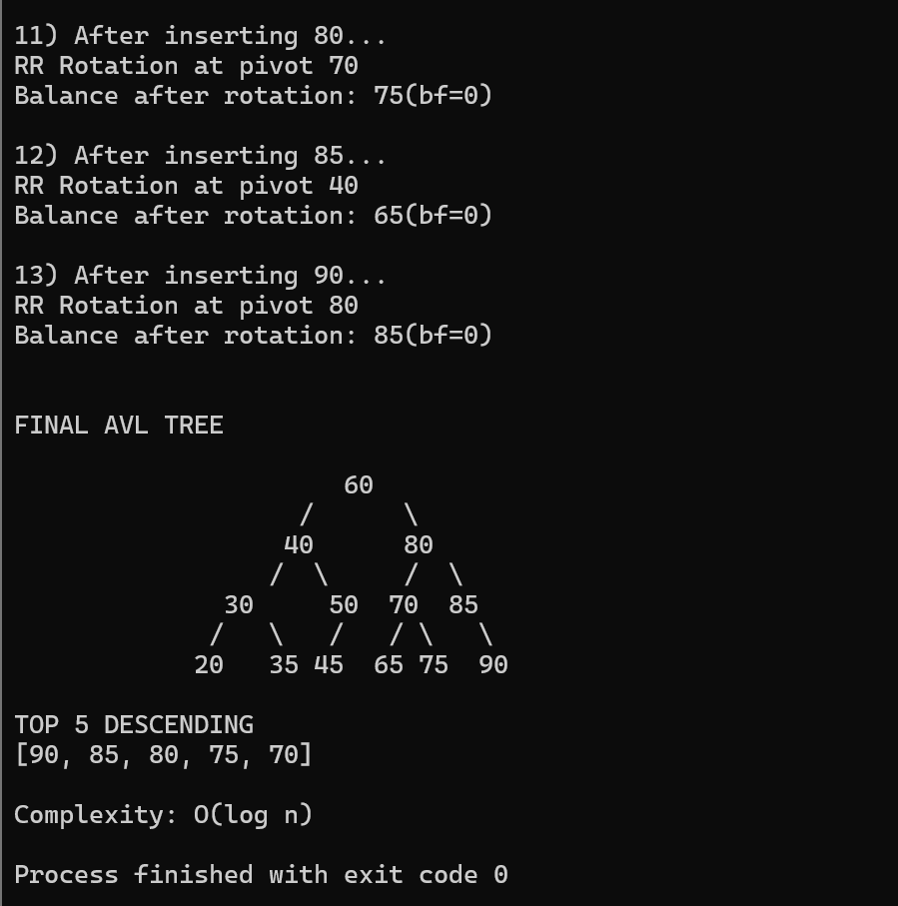
The AVL Tree provided efficient insertion, deletion, and lookup operations for MediFlow Hospital’s patient indexing system.
The final AVL Tree remained balanced even after multiple insertions and rotations.
The Top 5 Patient IDs retrieved were:
90, 85, 80, 75, 70
Time Complexity:
- AVL Insert/Delete : O(log n)
- AVL Search : O(log n)
- Top K Retrieval : O(log n + k)
Compared to a plain BST, the AVL Tree performs significantly better for nearly sorted appointment-order insertions because self-balancing prevents excessive tree height and guarantees faster lookup performance under the hospital SLA constraints.

url

